Create GitHub Account

Create Private Repository & Name it CFG-Assignments

Create README.md file with info about me

Use at least 6 different markdown text formatting features

***Shown above***

With a file(s) of your choice, demonstrate the following:  
1. Checking the status

2. Creating a branch

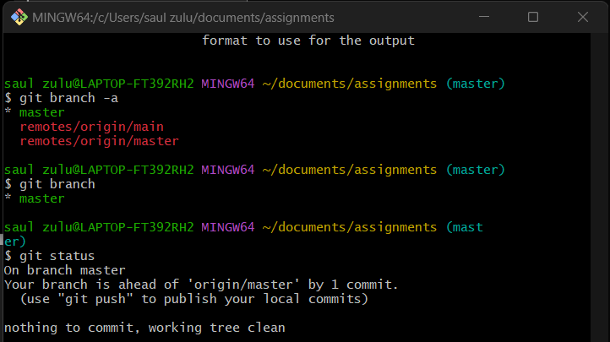

3. Adding files to a branch

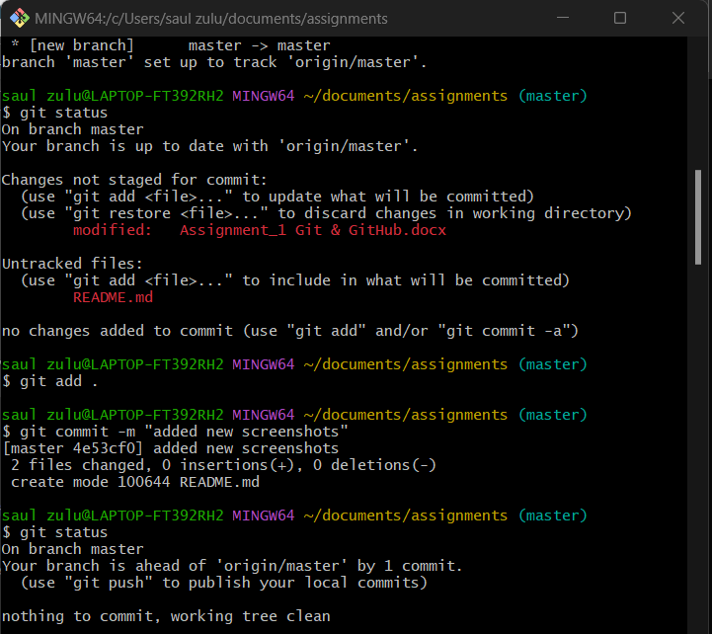

4. Adding commits with meaningful messages

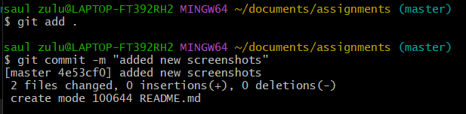

5. Opening a pull request

6. Merging and deploying to main branch



